**BURSTING**

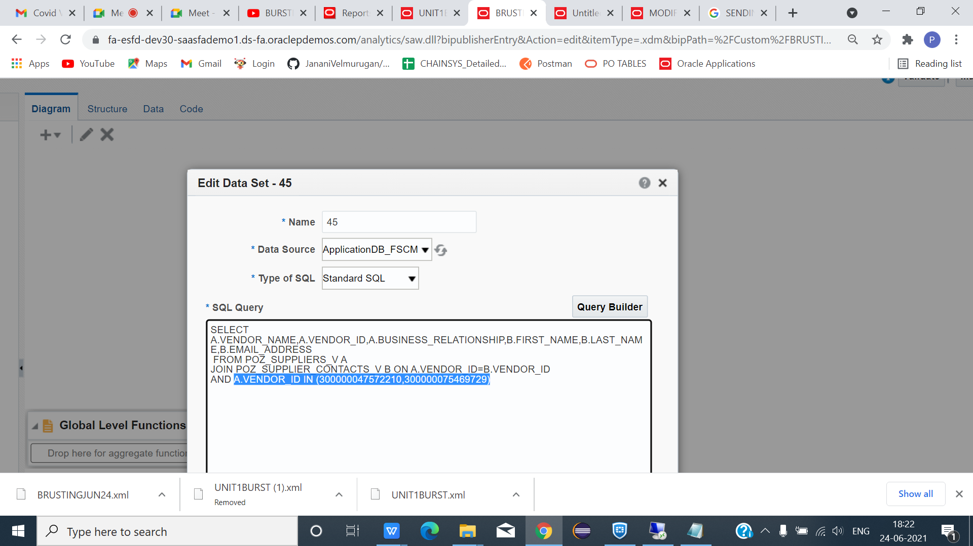

*SQL QUERY FOR BURSTING CONCEPT ->BURSTINGJUN24(DATA MODEL).

**DATAMODEL QUERY**

******************************************************************************

SELECT A.VENDOR_NAME,A.VENDOR_ID,A.BUSINESS_RELATIONSHIP,B.FIRST_NAME,B.LAST_NAME,B.EMAIL_ADDRESS

FROM POZ_SUPPLIERS_V A

JOIN POZ_SUPPLIER_CONTACTS_V B ON A.VENDOR_ID=B.VENDOR_ID

AND A.VENDOR_ID IN (300000047572210,300000075469729)

***********************************************************************************

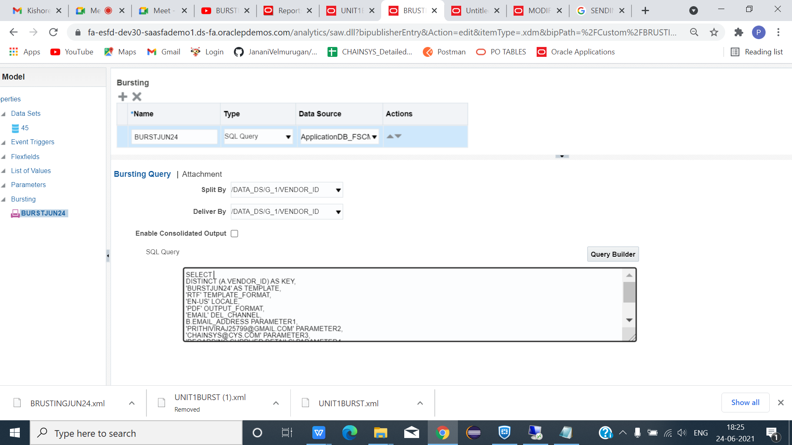

*CLICK + AND GIVE BURSTING NAME AND DATA SOURCE -> APPLICATIONDB_FSCM

*SPLIT BY -> VENDOR_ID AND DELIVER BY -> VENDOR_ID(ACCORDING TO WHICH WE SPLIT AND DELIVER MAIL) AND PASTE THE BURSTING QUERY. AND SAVE.

**BURSTING QUERY**

*******************************************************************************

SELECT A.VENDOR_NAME,A.VENDOR_ID,A.BUSINESS_RELATIONSHIP,B.FIRST_NAME,B.LAST_NAME,B.EMAIL_ADDRESS

FROM POZ_SUPPLIERS_V A

JOIN POZ_SUPPLIER_CONTACTS_V B ON A.VENDOR_ID=B.VENDOR_ID

AND A.VENDOR_ID IN (300000047572210,300000075469729)

**************************************************************************

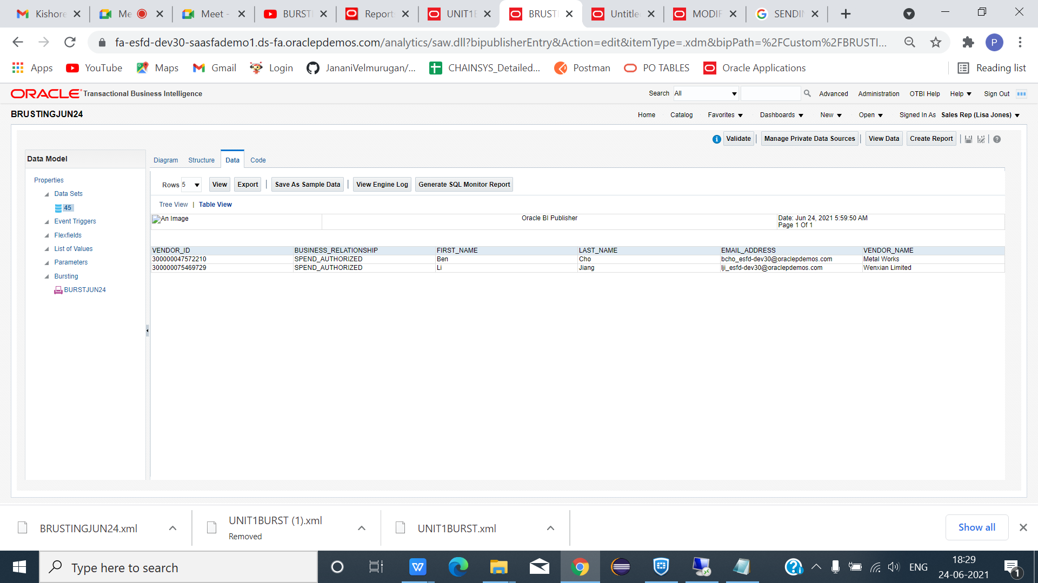

*CLICK SAVE AS SAMPLE DATA.

*CLICK CREATE REPORT AND DO STEPS AS USUAL AND SAVE LAYOUT NAME PROPERLY AS WE MENTIONED IN BURSTING QUERY(BURSTJUN24).

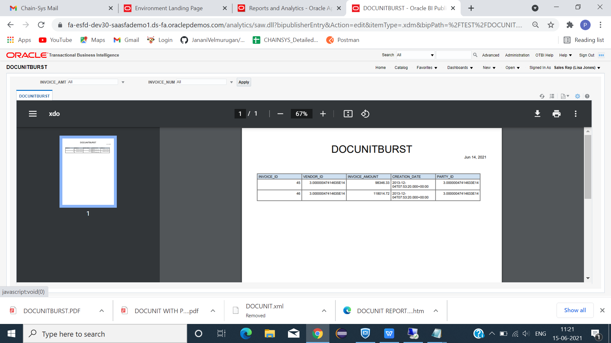

*CLICK DOWNLOAD IF WE NEED.CLICK CATALOG.

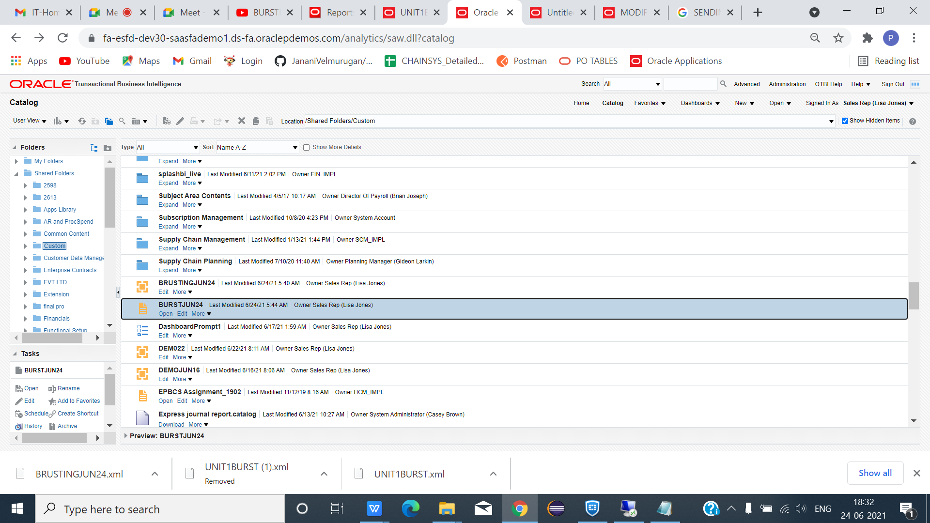

*CLICK EDIT ON DOCUNITBURSTJUN24.

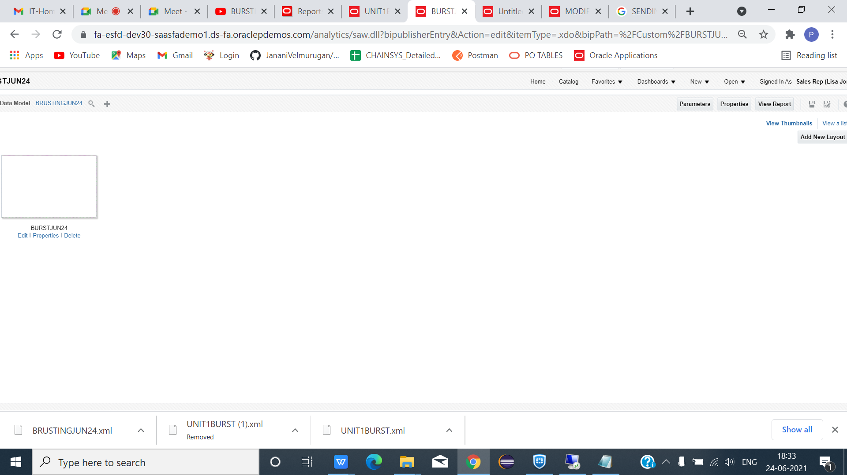

*CLICK PROPERTIES.

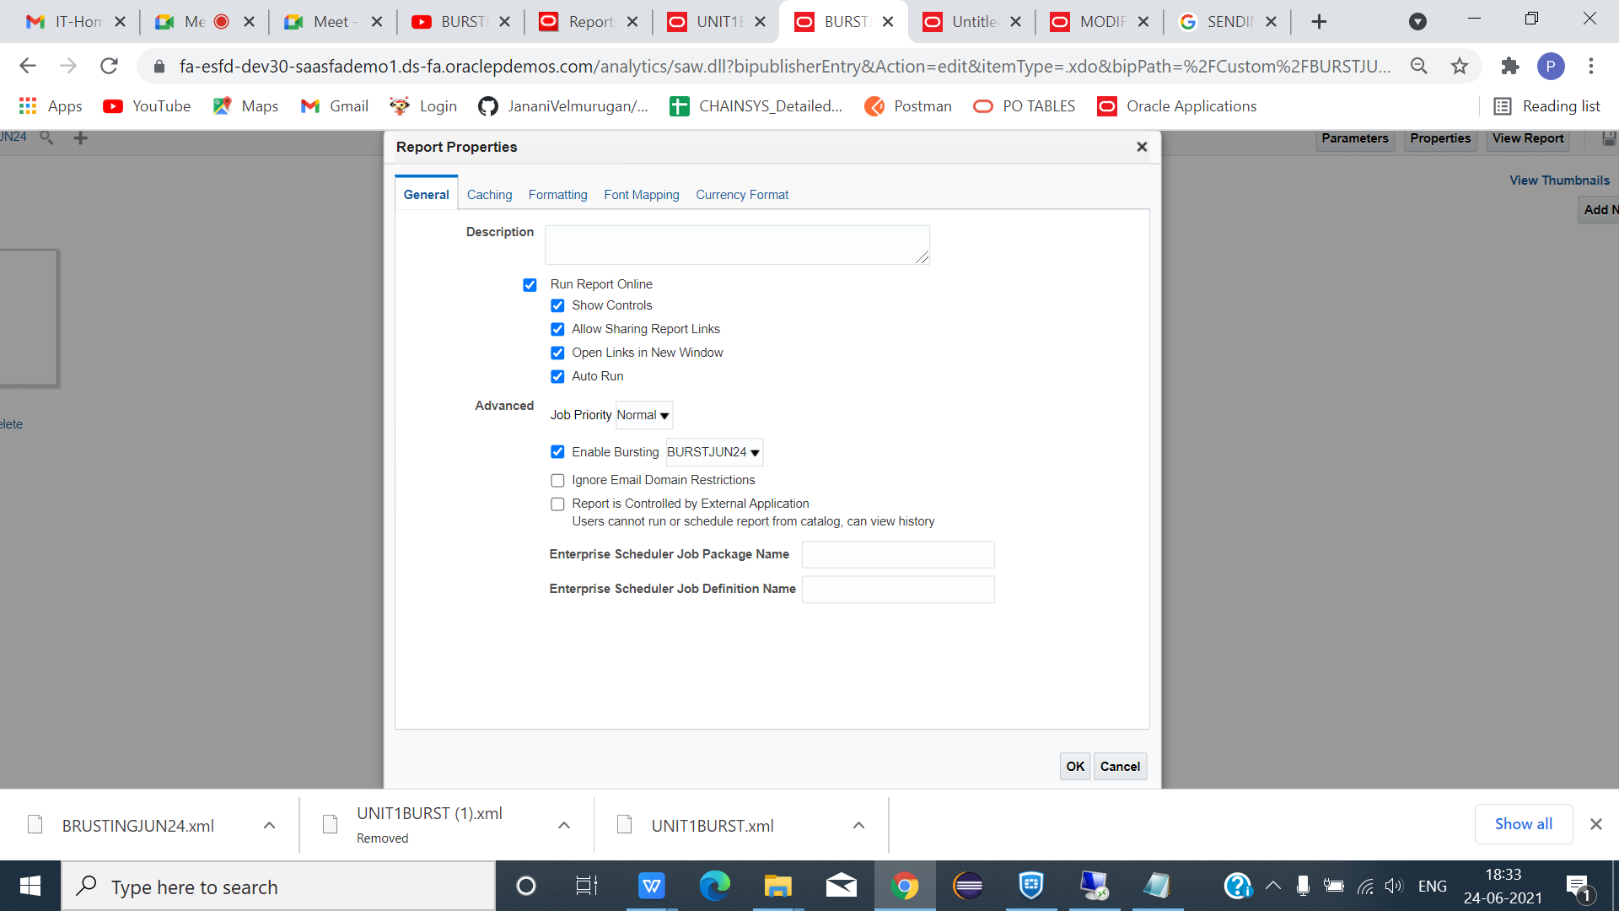

*ENABLE BURSTING ->OK AND CLICK CATALOG.

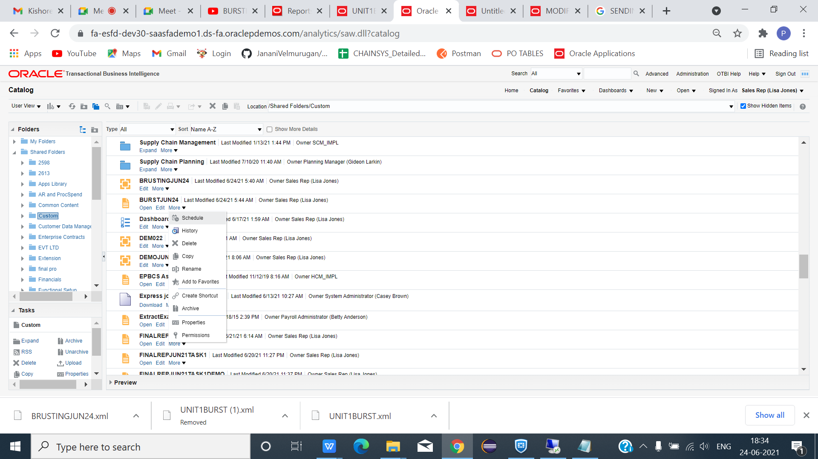

*BURSTJUN24->(MORE -> SCHEDULE).

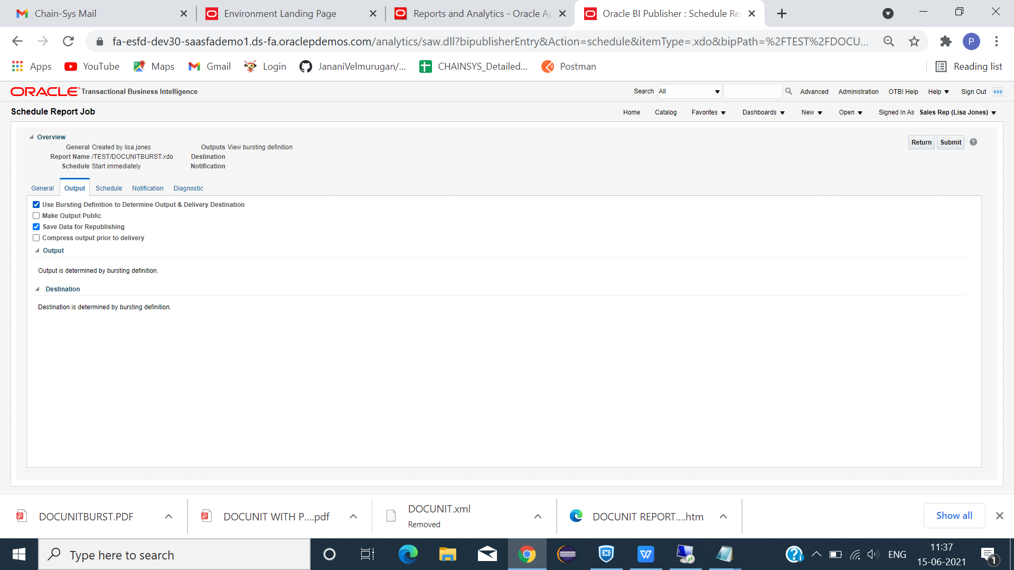

*SAME SCHEDULE PROCESS AS WE DONE PREVIOUSLY OUNTPUT AUTOMATICALLY ENABLES WITH USE BURSTING DEFINITION AS WE ARE USING BURSTING.

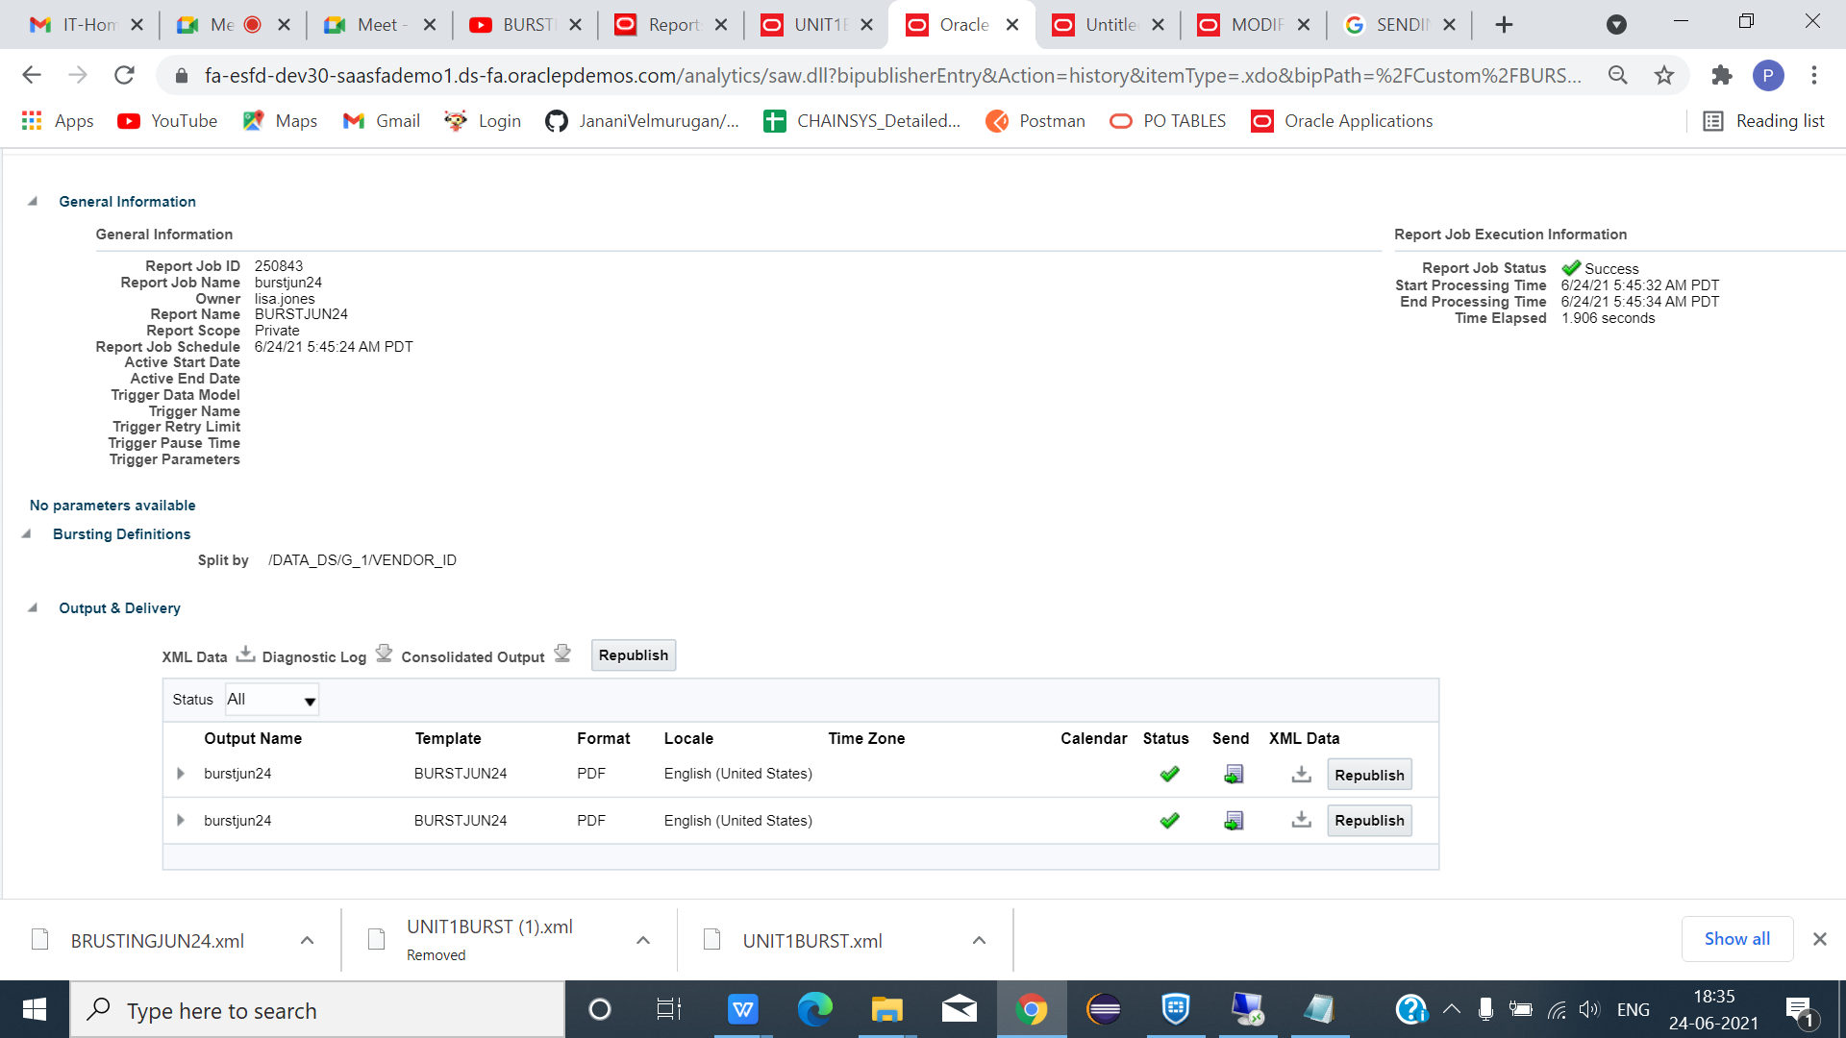

*CLICK BURSTJUN24 -> HISTORY -> CLICK TEMPLATE NAME -> TO VERIFY STATUS.

*MAIL RECEIVED SUCCESSFULLY DATA DIVIDE SEPERATELY AND RECEIVED.